Experiment-7

1.Display 1 to 5 student’s details.

SQL> Select * from student;

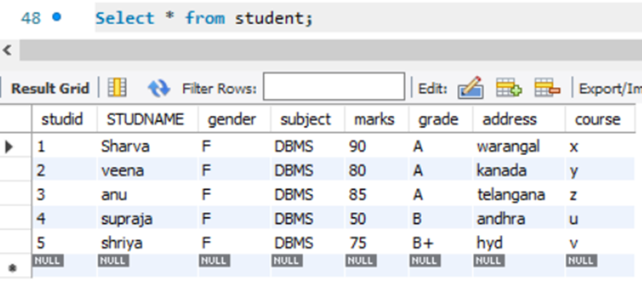

2.Display who got grade A

SQL> Select * from Student where grade =’A’;

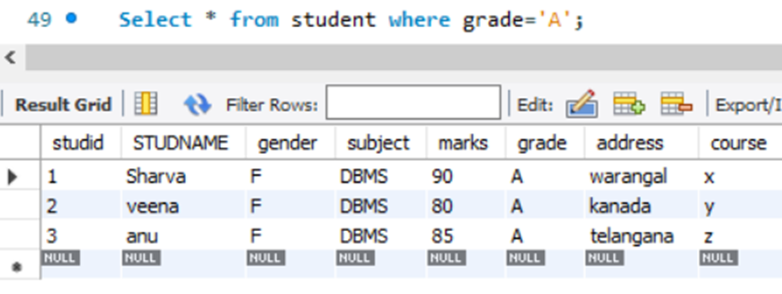

3.Display whose mark is less than 50

Select * from student where marks <50;

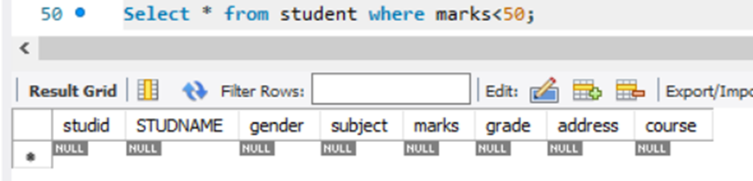

4.Display student id and name

SQL> Select studid, studname from student;

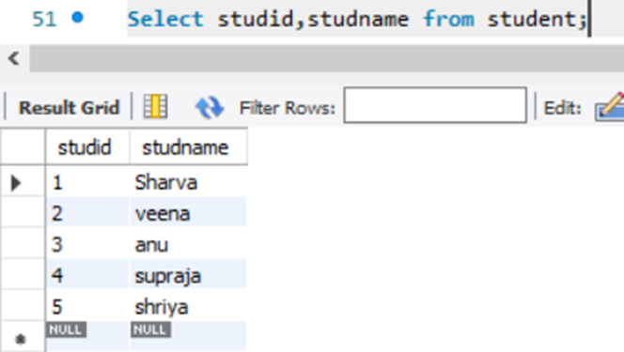

5.Display the student id and name whose mark is 50 to 60 and female

SQL> Select studid, studname from student where marks BETWEEN 50 AND 60 and gender=’f’;

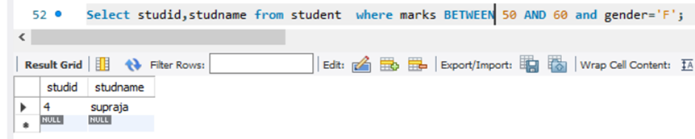

6.Display the list of students who gets greater than 70

SQL> Select *from student where marks >70;

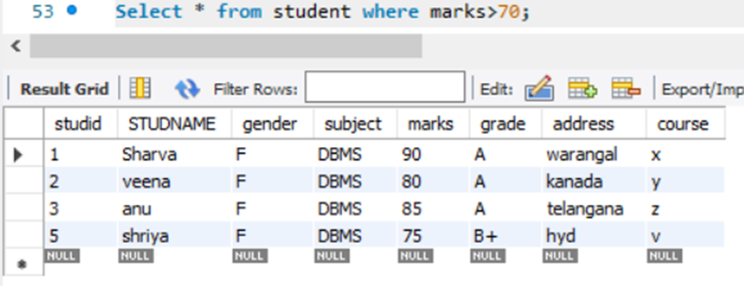

7.delete the failure students. Display complete table.

SQL>Delete from student where grade =’f’;

SQL> Select * from student;

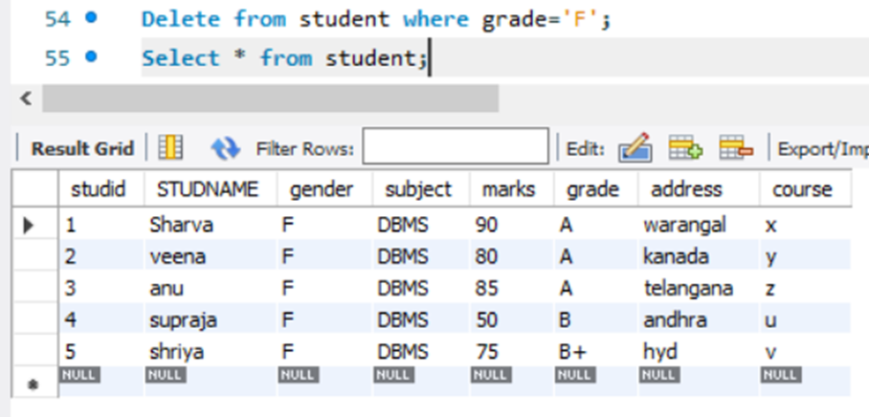

8.display activity id, name using object

SQL> Select a.act_id, a.act_name from activity a;

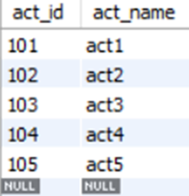

9.Add course to student table then insert values, display student id, faculty id using course name condition with object

